# **PSB**

**Configuration – Bank & Branch**  
Bug Report

Cycle 1

Afrida Rahman

Last Executed: 20/05/2024

1. Syntax error occur whenever tried to approve New Branch request. **(Solved:20.05.2024) -Fixed**

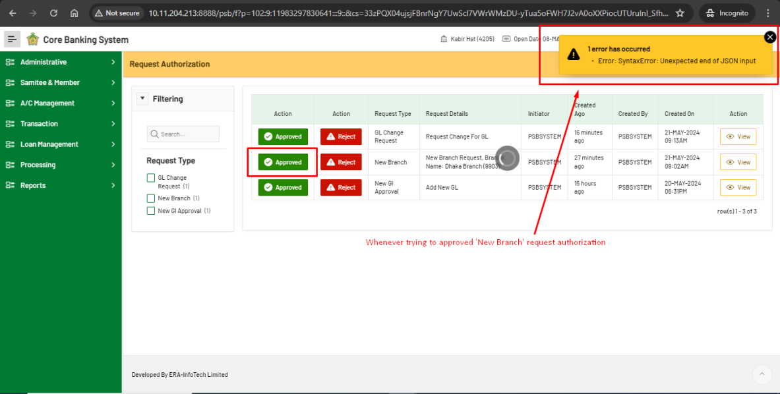

1. System should not suggest same branch code, once one branch creation is requested.

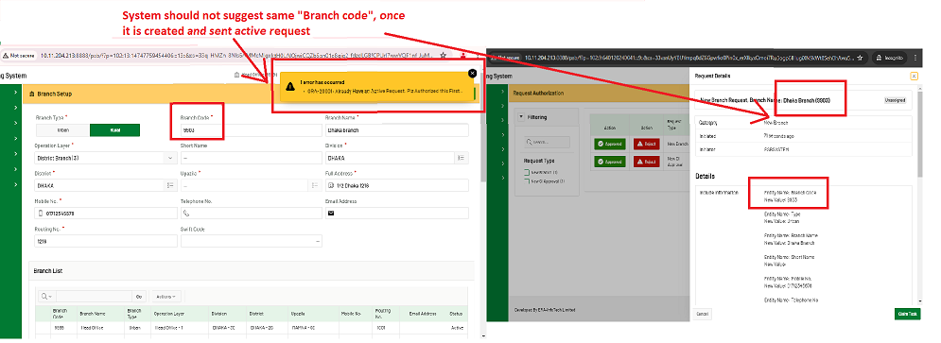

1. System should not suggest the branch code that is not created. **- Fixed**

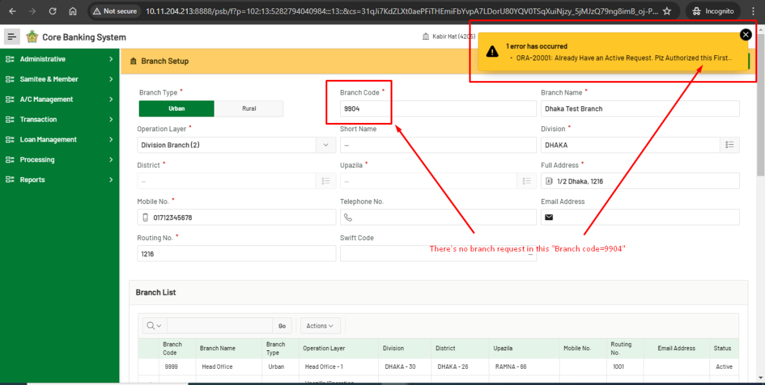

**Configuration – GL**  
Bug Report

Cycle 1

Afrida Rahman

Last Executed: 20/05/2024

1. System doesn't allow multiple GL Account Setup request branches to be created at a time.

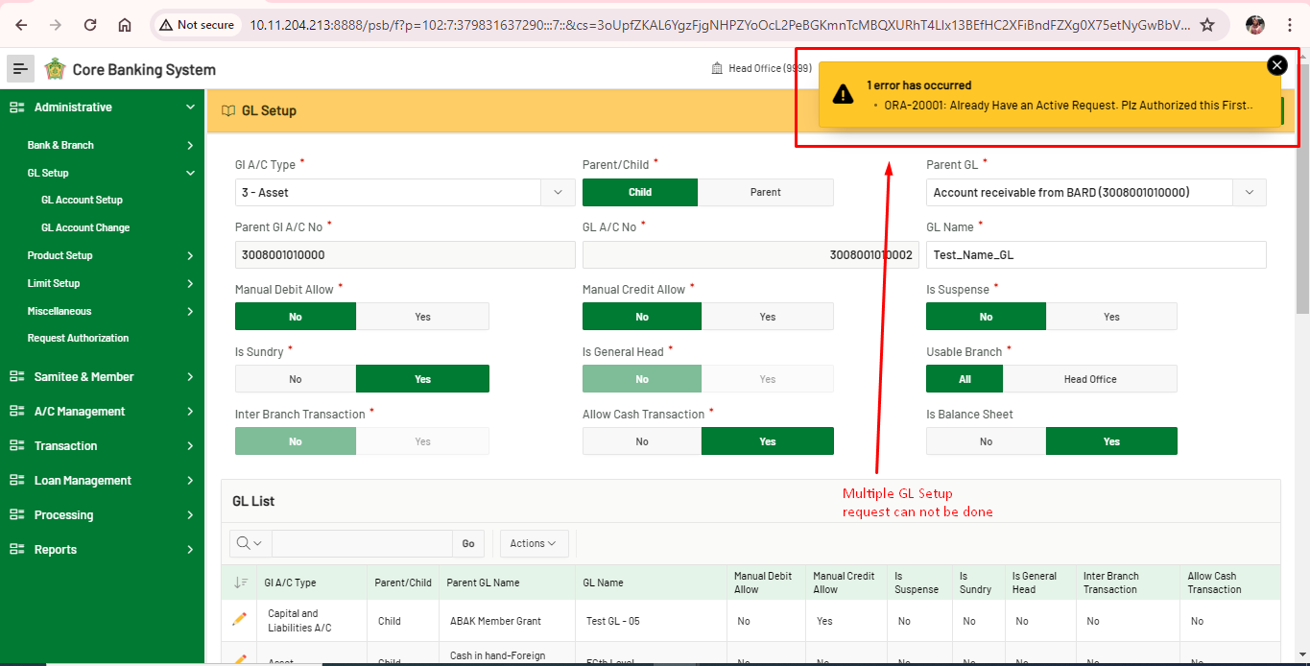

1. Nothing appears on “GL Account Change” tab.

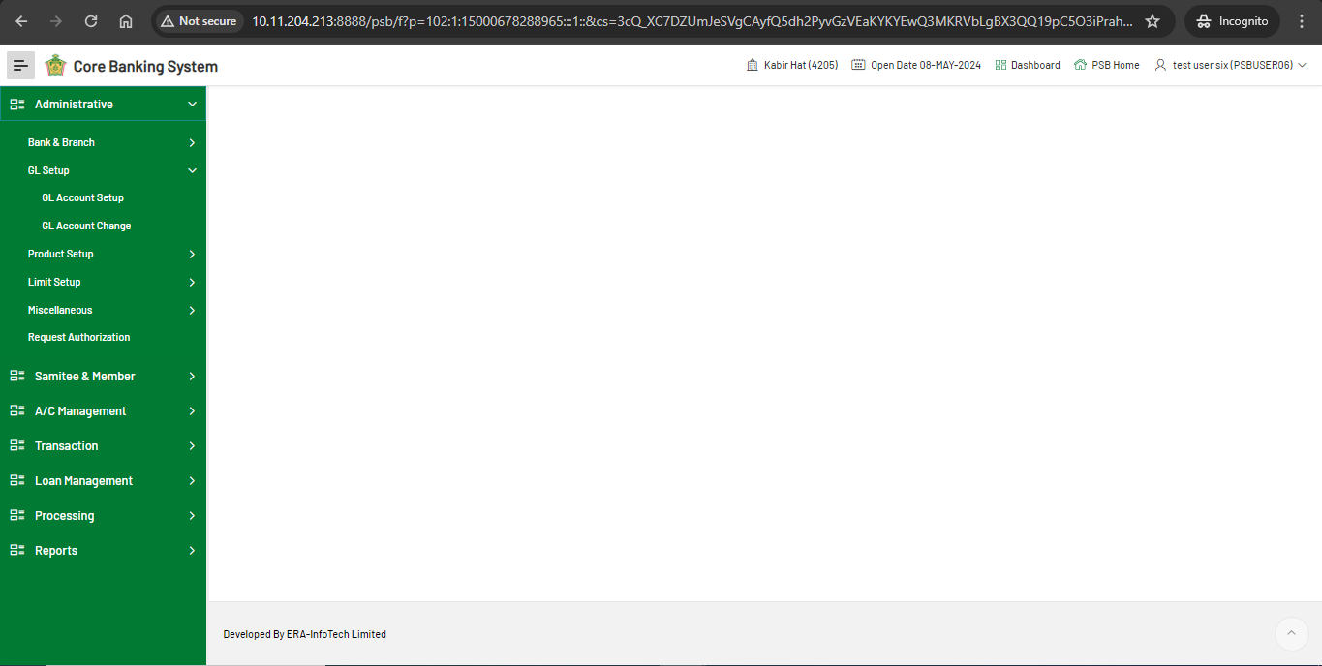

**Configuration – Miscellaneous, Holiday Setup**  
Bug Report

Cycle 1

Afrida Rahman

Last Executed: 20/05/2024

1. Holiday date error.

System should not accept “From date” greater than “To date”. (Solved- 21.05.2024)

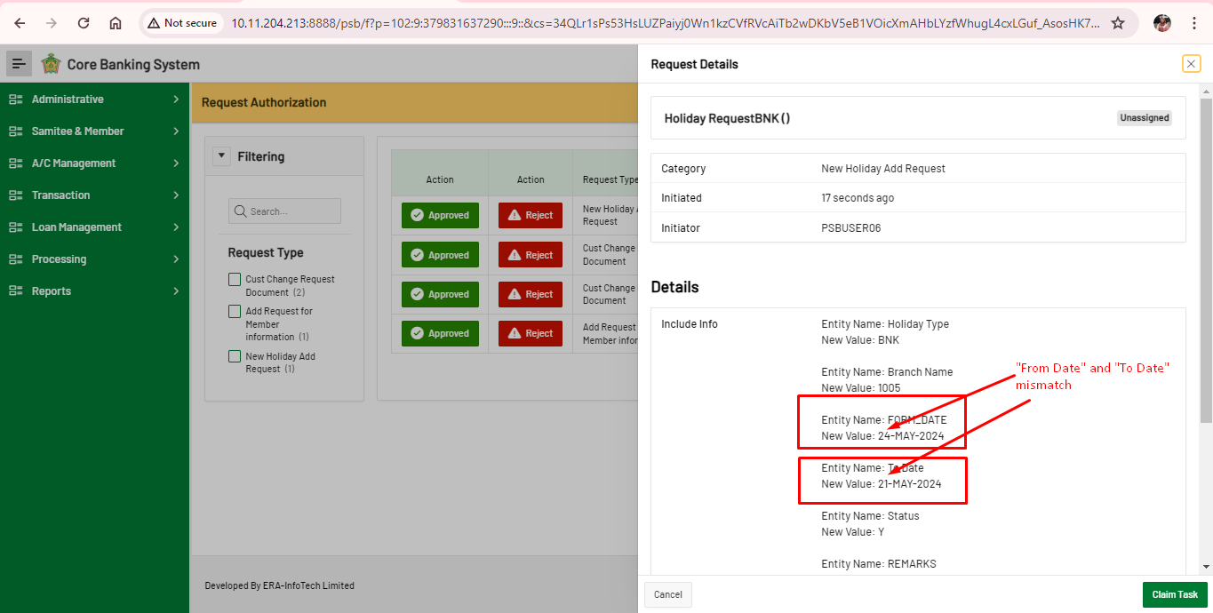

1. Holiday Request approval problem

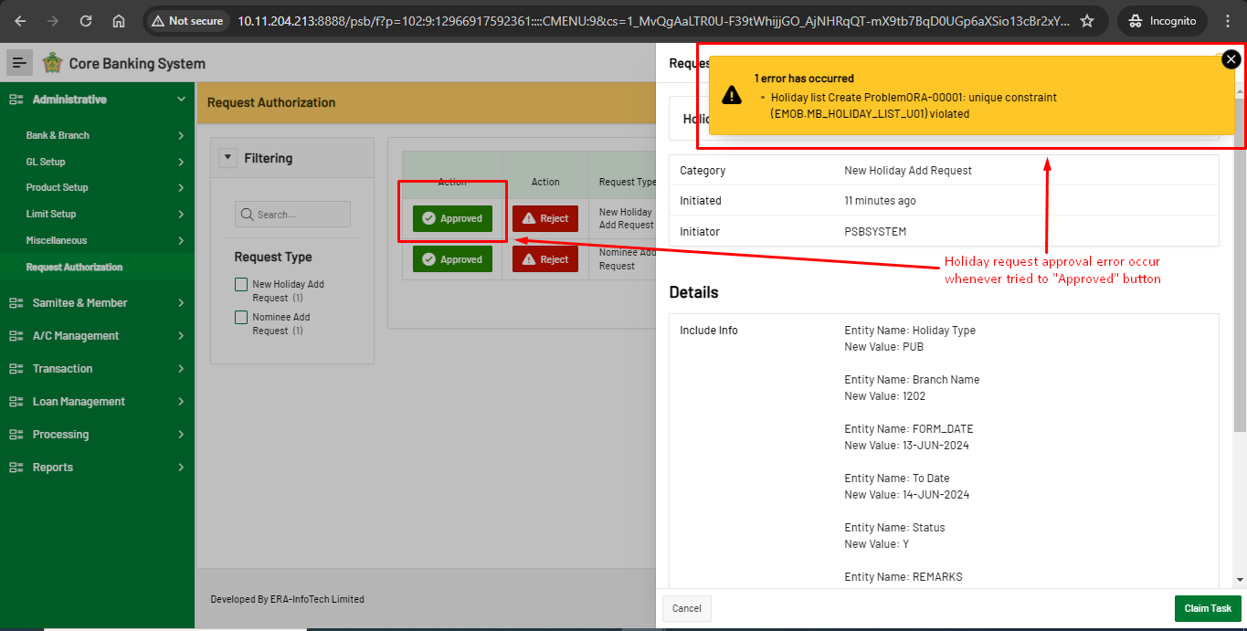

**Configuration – Product Setup, Asset Product**  
Bug Report

Cycle 1

Afrida Rahman

Last Executed: 21/05/2024

1. The “Interest posting period” field is not marked as a mandatory field.

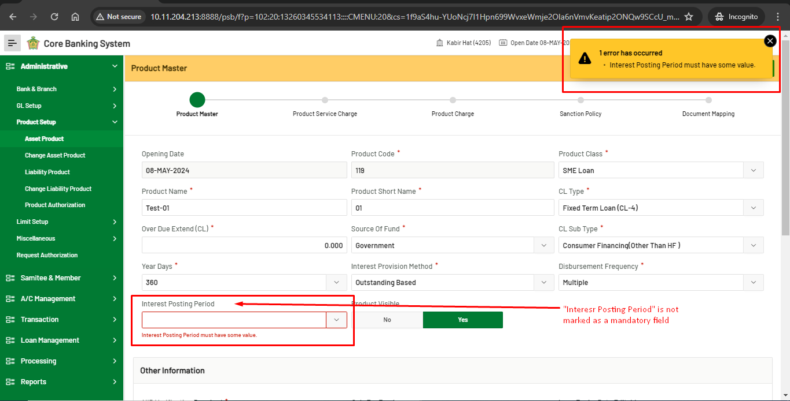

1. save button, renew the form and system does not allow for next step.

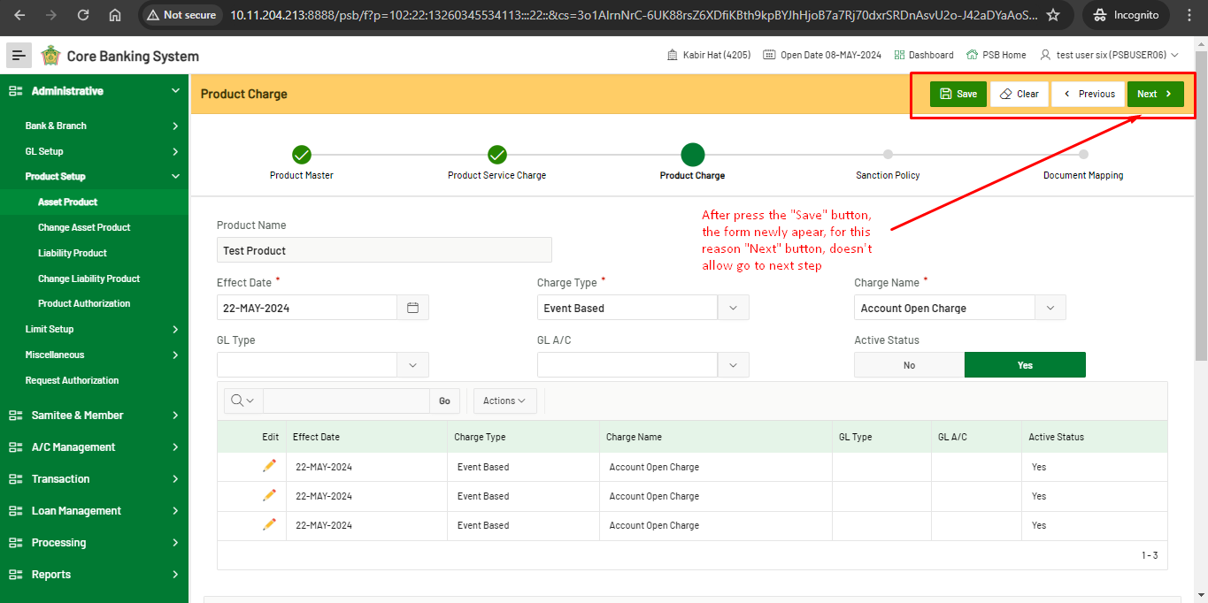For better understanding, screen recording attachment: [save button, renew the form and system doesnot allow for next step.mp4](https://erainfotechbd-my.sharepoint.com/:v:/p/afrida/EYNnP2KEu7JMrYiHaUpW0hIBQHSmkGTM449Qf8BaUfZxeQ?nav=eyJyZWZlcnJhbEluZm8iOnsicmVmZXJyYWxBcHAiOiJPbmVEcml2ZUZvckJ1c2luZXNzIiwicmVmZXJyYWxBcHBQbGF0Zm9ybSI6IldlYiIsInJlZmVycmFsTW9kZSI6InZpZXciLCJyZWZlcnJhbFZpZXciOiJNeUZpbGVzTGlua0NvcHkifX0&e=S94Gnd)

1. Product authorization error, whenever tried to approve the asset product.

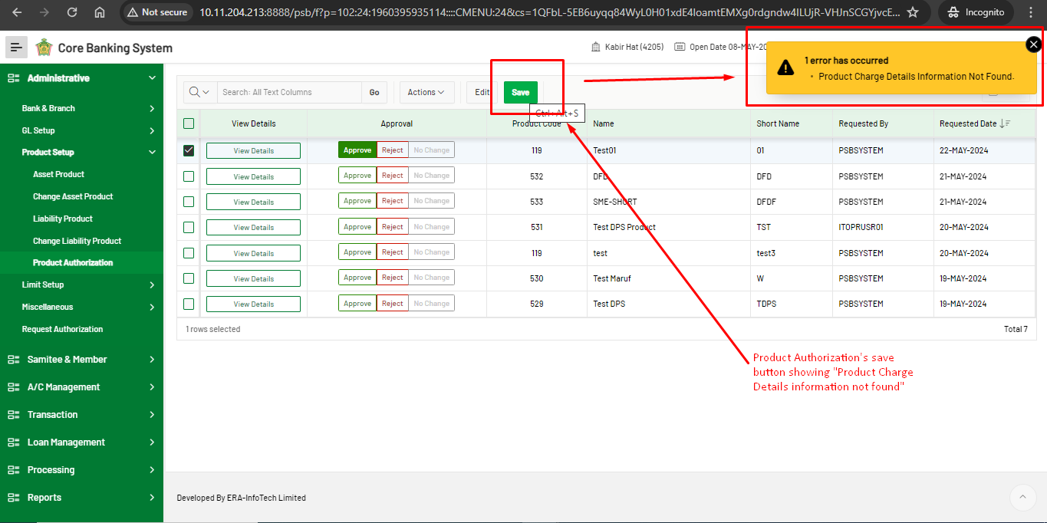

**Configuration – Reports**  
Bug Report

Cycle 1

Afrida Rahman

Last Executed: 22/05/2024

**Account Statement**

1. In SRS "To Date" will be current module date. but in system the "To Date" is not matching according to SRS

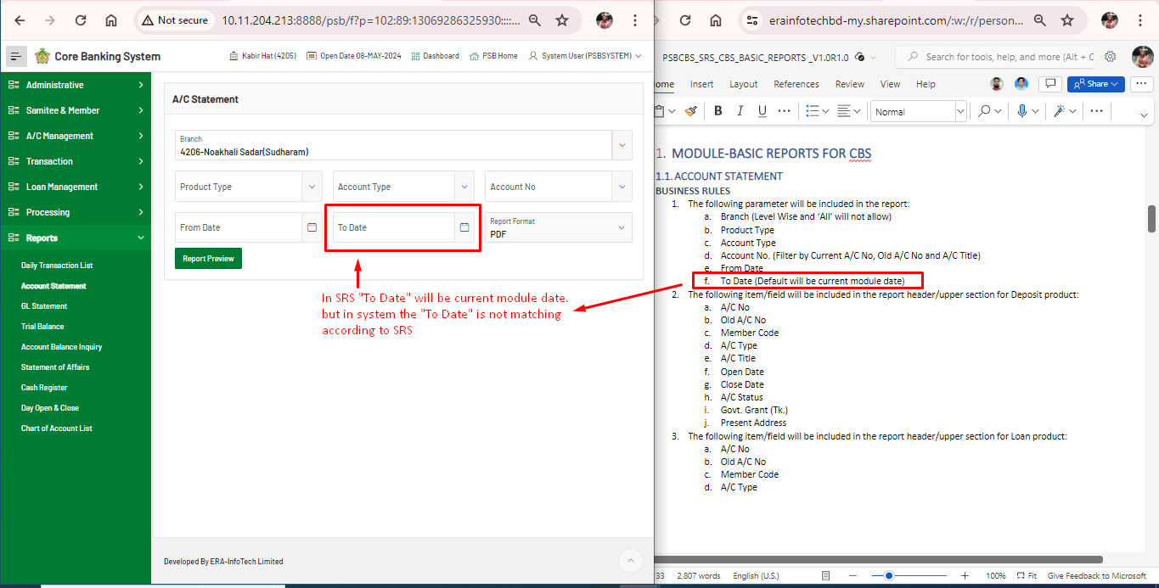

2. Mismatch between SRS and System. (There's no mandatory field marked as per SRS)

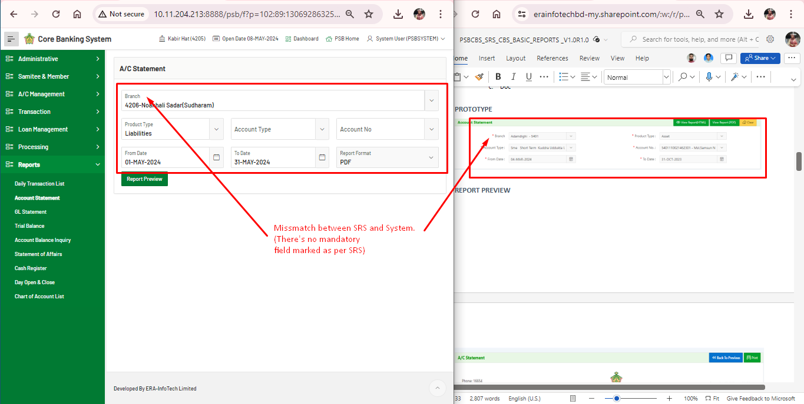

1. Mismatch in generated view report between SRS and Generated Report.

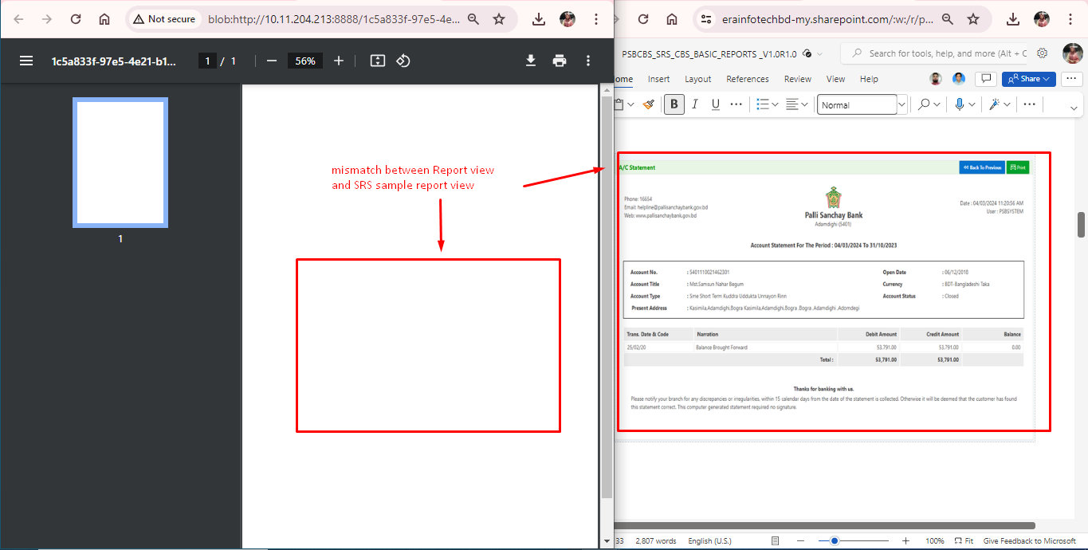

**Account Balance Parameter**

1. Mismatch field name on between SRS and System in Account Balance Inquiry

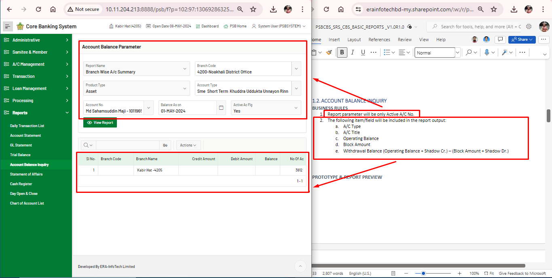**Daily Transaction List**

1. Mismatch between SRS and System. In SRS the "Date" will take the default current module date. Which is missing on the System

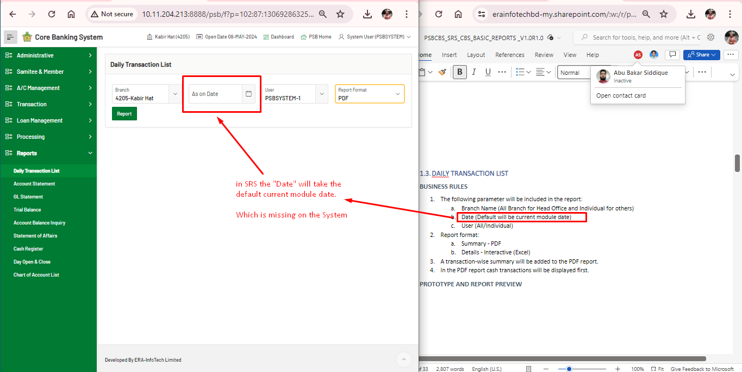

1. Generated PDF report shows nothing, it is not as per SRS

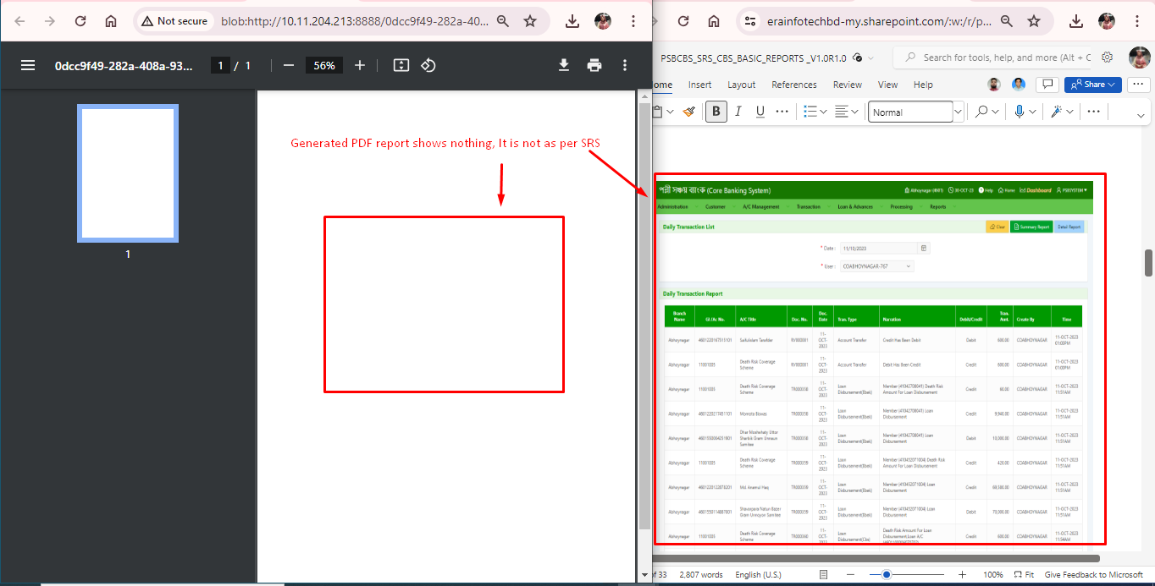

1. Missing “Reverse Transaction Report” in Reports, which is written in SRS. There’s no module in the Reports section name.

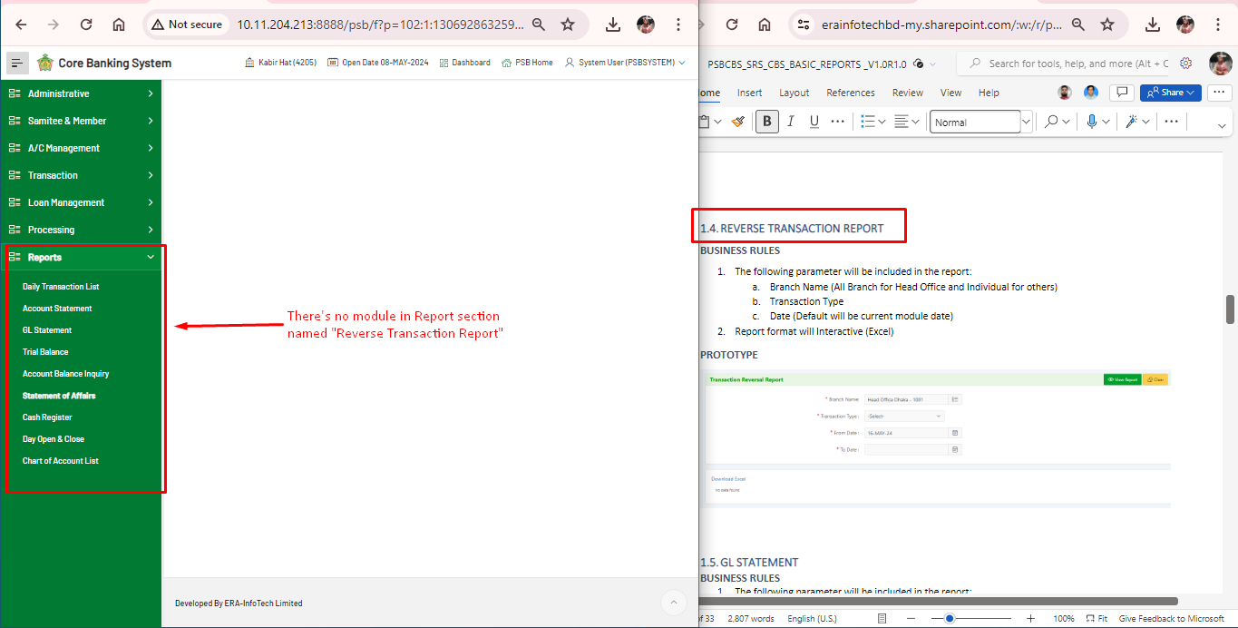

**GL Statement**

1. In generated report, Time mismatch between the System and User's operating system.

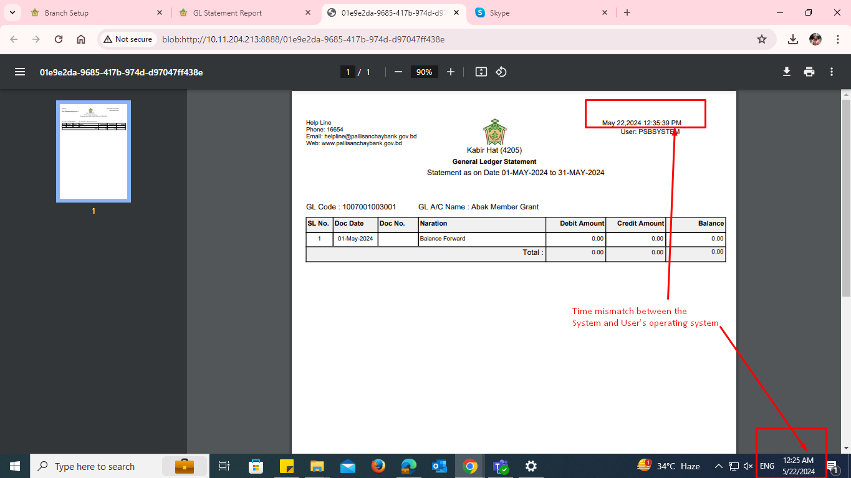

1. GL Account balance report is not the same as SRS.

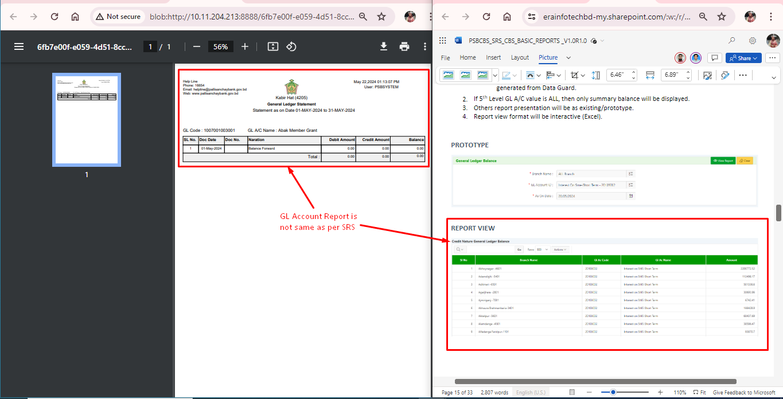

**GL Statement**

**Trial Balance**

1. Trail balance report is not as same as described in SRS

